Chilli Studios
Social Media & Privacy
Policy

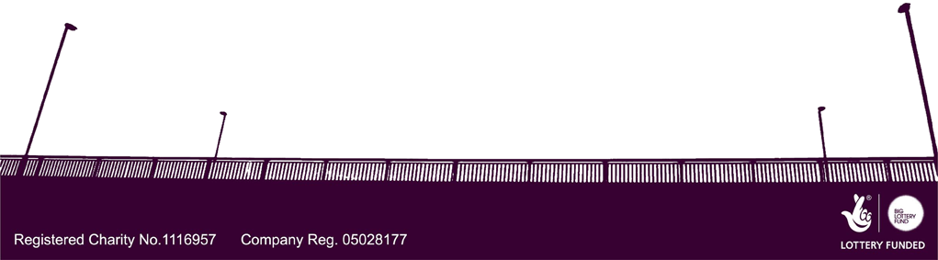
[Created: 09-11-15]
Date Modified: 25-04-16
Modified by: Nikki Heeley

Social Media & Privacy Policy

1. Introduction
The Chilli Studios Social Media & Privacy policy is designed to provide all management, staff, employees, volunteers and members with a basic policy on their use of social media.
Social Media is a valuable service fort Chilli Studios, it enables a greater number of people to become engaged in the service the organisation provides and helps to circulate the good work that the studio does on a day-to-day basis. However using social media in the wrong way could damage the reputation of the organisation.
Also for the purposes of compliance, and as a registered charity, Chilli Studios abides by the Data Protection Act, 1998. Chilli Studios recognises the individual’s freedom of expression but reserves the right to provide clear guidelines on the use of social media in relation to topics relating to the organisation.

2. Scope & Purpose of this policy
The purpose of this policy is to minimise risks to our business through the use of social media. This policy deals with all forms of social media such as social networking sites including: Twitter, Facebook, LinkedIn, Snapchat, Tumblr, Pinterest, YouTube, Instagram, WhatsApp, and any other related sites e.g. personal blogs.
Chilli Studios staff, volunteers, and members, are expected to comply with the Social Media Policy at all times, for both business and personal purposes.

3. Breaches of the Policy
Whether accessed at work or not, the following can result in disciplinary action:
- Use of a site where Chilli Studios or your individual duty of confidentiality is breached.
- Where the dignity at work of colleagues, volunteers, or members are undermined.

- If the values of Chilli Studios are compromised, where any other policies are breached

4. Use of Social and Business Social Media (and other related sites e.g. personal blogs/forums)
Social Media should never be used in a way that breaches any of the policies established by Chilli Studios. The following are guidelines to using social media appropriately:
4.1 Personal Use
- Chilli Studios respects that staff, volunteers and members use social media on a personal basis. Where Chilli Studios is referred to in any way during personal use of social media, it is expected that permission is provided in advance by the organisation and any individuals portrayed
4.2 Best Interests
- It is expected when using social and business media to act in all situations in the best interests of Chilli Studios
4.3 Disrepute
- Social Media must not be used in any way that would tarnish the interests or reputation of Chilli Studios whether directly or indirectly
- Social Media must not be used to defame or disparage Chilli Studios, or the individuals working in, or using the service. It must not be used to harass; bully; or unlawfully discriminate against the above or third parties; to make false or misleading statements; or to impersonate the above individuals/groups or third parties

4.4 Confidentiality
- It is against policy to publish contact details or pictures of any staff, volunteers, members, supporters and young people without express permission to do so from the parties concerned and the studio manager
4.4.1
- Confidential information is defined as any information that includes personal information about staff, volunteers, members, supporters, third parties, press releases, and any information not already made legitimately available to the public. Any information which relates to the commercial, financial and other activities of Chilli Studios.
- Information shared on social and business networking sites, or personal blogs or private spaces are still subject to copyright, data protection and defamation laws and may give rise to claims against the individual or Chilli Studios.
- Please note that once a comment online has been made it is difficult to remove the comment without any repercussions due to the fast-moving nature of social media

